Date | Homework
Monday 10/16 | Math: Study!  Phonics: Share Sheet #4
Tuesday 10/17 | Math: Chapter 3 Test!  Phonics: Share Sheet #4 due!
Wednesday 10/18 | Math: None  Phonics: Flashcards
Thursday 10/19 | Math: 4.1  Phonics: Share Sheet #5
Friday 10/20 | Read, Read, Read!!
Mrs. VanAsdlen’s Weekly Newsletter:
October 16th – 20th

Special Notes!
- Conference sign up packets will be sent home on Monday! Please sign up for three time slots that would work and I will do my best to accommodate those times. Conferences will be on Monday, November 20th and Tuesday, November 21st.
- MES Book Fair will be taking place next week. On Monday, students will have a chance to browse at the book fair as a class. Then, the remainder of the week, they will be sent down with our aide to buy books.
- As of last Friday, our new building policy is that NO birthday invitations are going to be able to be passed out at school. Please use the Kindergarten directory we sent home in the beginning of the year to send invites through the mail. Sorry for the confusion and any inconvenience.

Phonics:
- Frieze 6- students will recognize, write and know the sounds for y, x, ch, and sh. Please practice flashcards daily!
- Tricky Words- students will recognize and spell: go, no, so (these words are “tricky” because they cannot be sounded out).
- Share Sheet #4 will be due on Tuesday, October 17th.
- Share Sheet #5 will be sent home later this week as well.

** As well as the homework listed above, I encourage your child to study his or her spelling words and dictation sentences on a nightly basis to prepare them for the test. Please also read for at least 20 minutes a day. This helps build their fluency, comprehension and love for reading! **

** As well as the homework listed above, I encourage your child to study his or her spelling words and dictation sentences on a nightly basis to prepare them for the test. Please also read for at least 20 minutes a day. This helps build their fluency, comprehension and love for reading! **

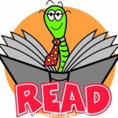
Reading Strategy:
Good readers use all different reading strategies while reading. This week we will focus on predicting, retelling, building schema, comparing using a Venn Diagram and sharing opinions using the story Stellaluna.

Math
Students will be taking the Chapter 3 test on Tuesday, October 17th. Following, we will begin Chapter 4 Represent and Compare Numbers to 10.

** As well as the homework listed above, I encourage your child to study his or her spelling words and dictation sentences on a nightly basis to prepare them for the test. Please also read for at least 20 minutes a day. This helps build their fluency, comprehension and love for reading! **

Upcoming Events:
- 10/20 PTO Store & Bux
- 10/23-10/27 –PTO Book Fair
- 10/27 Trunk-or-Treat Parade @ 10:00a.m.
- 10/27 5 Hour Day!
- 10/27 Fall Fest from 6-8 p.m. for MES families
- 10/30 No School-Teacher Institute
- 10/31 Halloween

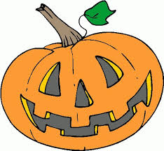
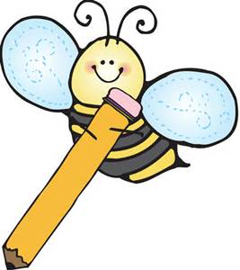
Writing
This week we will continue our scientific method of asking questions, making a hypothesis, and conducting our Growing Pumpkin Seeds experiment.
Contact Mrs. VanAsdlen:
mvanasdlen@min201.org
815.467.2261 ext. 1104

