Date | Homework
Monday 9/25 | Math: None  Phonics: Practice Flashcards
Tuesday 9/26 | Math: 3.1  Phonics: Practice Flashcards
Wednesday 9/27 | Math: 3.2  Phonics: Share Sheet #3
Thursday 9/28 | Math: 3.3  Phonics: Share Sheet #3
Friday 9/29 | Read, Read, Read!!!
Mrs. VanAsdlen’s Weekly Newsletter:
September 25th – 29th

Special Notes!
- Please remember to send one apple to school with your child on Tuesday, September 26th to celebrate Johnny Appleseed’s birthday!
- Picture Day is Monday, October 2nd!
- PTO store is Friday and box top collections for Baxter Bux on due this Thursday.

Phonics:
- Frieze 4- students will recognize, write and know the sounds for diagraph /ai/, j, diagraph /oa/, /ie/.
- Tricky Words- students will recognize and spell: all, are (these words are “tricky” because they cannot be sounded out).
- Share Sheet #3 will be sent home on Wednesday, September 27th and due the following Wednesday.

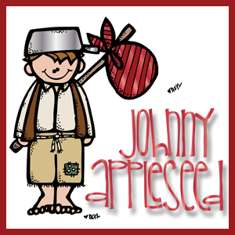
Reading Strategy:
Summarizing and Retelling
When we learn to retell and summarize, we can understand, review, and organize the events and information from the text. This week students will use the summarizing strategy—somebody, wanted, but, so, then.

** As well as the homework listed above, I encourage your child to study his or her spelling words and dictation sentences on a nightly basis to prepare them for the test. Please also read for at least 20 minutes a day. This helps build their fluency, comprehension and love for reading! **

** As well as the homework listed above, I encourage your child to study his or her spelling words and dictation sentences on a nightly basis to prepare them for the test. Please also read for at least 20 minutes a day. This helps build their fluency, comprehension and love for reading! **

Math
This week students will begin Chapter 3 Represent, Count, and Write Numbers 6-9.

** As well as the homework listed above, I encourage your child to study his or her spelling words and dictation sentences on a nightly basis to prepare them for the test. Please also read for at least 20 minutes a day. This helps build their fluency, comprehension and love for reading! **

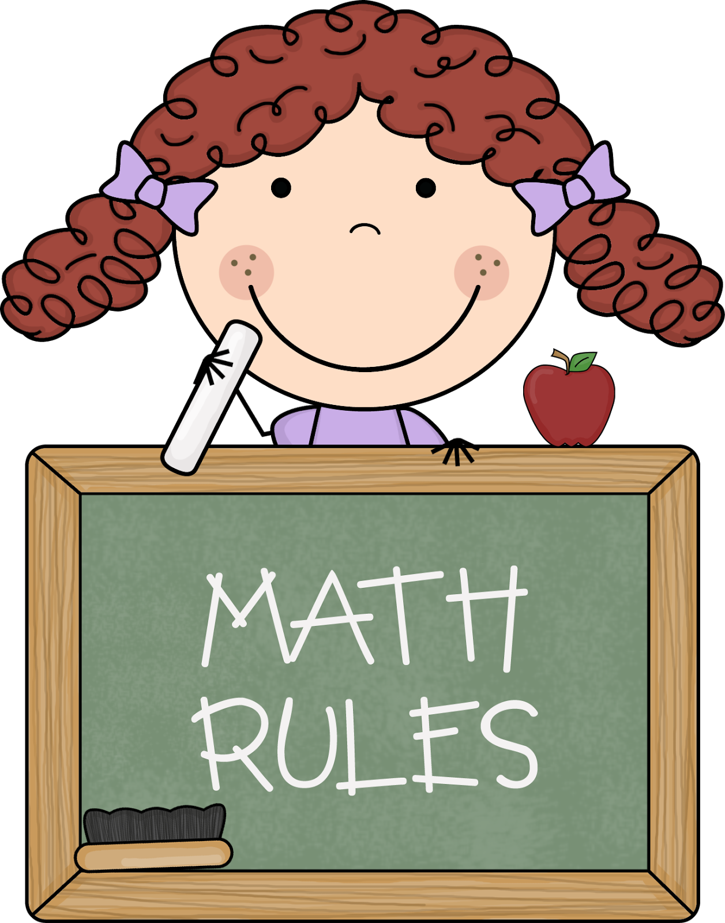
Writing
The beginning of Kindergarten writing is all about inventive spelling. If you have noticed your child labeling or spelling words that are not complete, this is OKAY! Inventive spelling is all about writing the sounds your child hears. Labeling pictures with words is the beginning stage of an independent writer. As your child learns more letter combination sounds, their writing will progress as well. This week our writing theme will be Fall Senses & Farms.
Upcoming Events:
- 9/26- Johnny Appleseed Day!
- 9/28- Jerry Jacoby Assembly
- 9/29- PTO Store
- 10/2- Picture Day!
- 10/5—Fire, Fire Cindy Assembly
- 10/6- PTO Store & 5 Hour Day!

Contact Mrs. VanAsdlen:
mvanasdlen@min201.org
815.467.2261 ext. 1104

