Date | Homework
Monday 9/11 | Math: None (Ch. 2 Intro)
Tuesday 9/12 | Math: 2.1
Wednesday 9/13 | Math: 2.2  Phonics: Share Sheet #2
Thursday 9/14 | Math: 2.3  Phonics: Share Sheet #2
Friday 9/15 | Read, Read, Read!!!
Mrs. VanAsdlen’s Weekly Newsletter:
September 11th – 15th

Special Notes!
- If you have not already, please sign up for the Minooka School District 201 phone app. You can download it from your cell phone app store. Please also sign up for a TeacherEase account. You can do this from our District 201 web site. Follow the TeacherEase sign up link to directions for this email and communication system. All school wide information is sent through TeacherEase and the District 201 app.
- Packing the Piggies collection is this week! Please send any loose change to support our school!
- Our Kindergarten Dollinger’s Field Trip is quickly approaching. The permission slip will be going home this week, please read carefully and return as soon as you can!

Phonics:
- Frieze 3- students will recognize, write and know the sounds for letters g, o, u. Please continue practicing the letters your child has already learned using the flashcards sent home at the end of each frieze.
- Tricky Words- students will recognize and spell: me, we (these words are “tricky” because they cannot be sounded out).
- Share Sheet #2- Due Wednesday, September 20th.

** As well as the homework listed above, I encourage your child to study his or her spelling words and dictation sentences on a nightly basis to prepare them for the test. Please also read for at least 20 minutes a day. This helps build their fluency, comprehension and love for reading! **

** As well as the homework listed above, I encourage your child to study his or her spelling words and dictation sentences on a nightly basis to prepare them for the test. Please also read for at least 20 minutes a day. This helps build their fluency, comprehension and love for reading! **

Math
This week we will begin Chapter 2 Compare Numbers to 5.

Reading Strategy:
Retelling & Making Connections
When we learn to retell, we can understand, review, and organize the events and information from the text. When students connect their reading to their own lives and to other books, we enrich our reading experience.

** As well as the homework listed above, I encourage your child to study his or her spelling words and dictation sentences on a nightly basis to prepare them for the test. Please also read for at least 20 minutes a day. This helps build their fluency, comprehension and love for reading! **

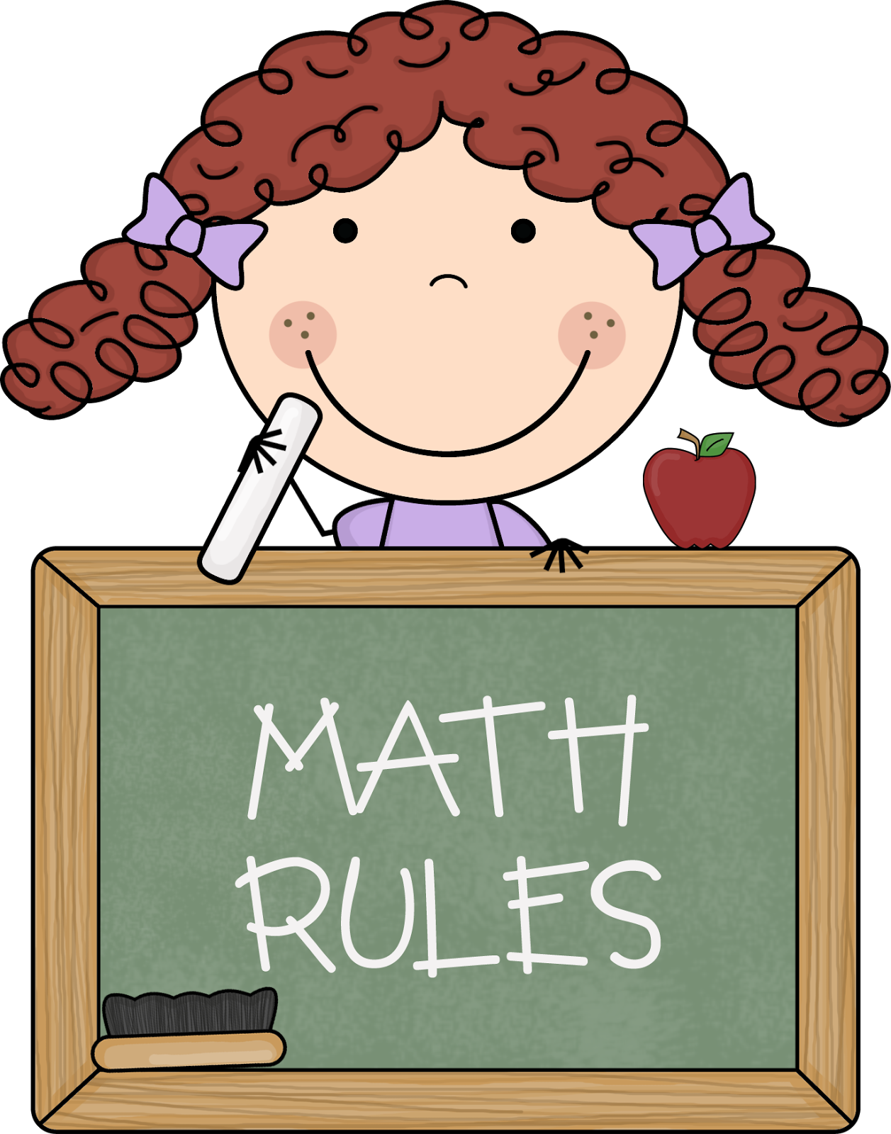
Upcoming Events:
- 9/11– Patriot’s Day celebration
- 9/11-9/15 Pack the Piggies
- 9/12- AIMSweb Testing
- 9/21- Dad’s Night @ 6:00 p.m.
- 9/22- 5 hour Day! & First Day of Fall
- 9/26- Johnny Appleseed Rotation
Writing
We will be focusing on the first 3 steps of writing in Kindergarten with our Apple Unit for September.
- Think of an idea
- Draw their idea with good detail
- Label their drawing using inventive spelling
Contact Mrs. VanAsdlen:
mvanasdlen@min201.org
815.467.2261 ext. 1104

