Date | Homework
Monday 1/8 | No School!
Tuesday 1/9 | Math: None  Phonics: Share Sheet #8
Wednesday 1/10 | Math: 6.1  Phonics: Share Sheet #8
Thursday 1/11 | Math: 6.2  Phonics: Share Sheet #8
Friday 1/12 | Read, Read, Read!
Mrs. VanAsdlen’s Weekly Newsletter:
Janurary 8th - 12th

Special Notes!
- Welcome back and Happy New Year! I hope you all enjoyed a wonderful winter break and are excited for the second half of your child’s Kindergarten year. I know I am!
- Scholastic Book order for January will be going home this week and are due by Thursday, January 18th.
- Winter is here and more snow is coming! Please remember to send the MAGIC 5 with your child when there is snow. The MAGIC 5 includes: hat, gloves, boots, snow pants, and a coat. All students must have their MAGIC 5 with them in order to play in the snow during the winter season. All children without snow pants and boots will play on the blacktop area.

Read, Read, Read!
Continue building a love for reading with your children at home!
January reading logs are due at the end of the month for a Pizza Hut coupon.
Six flags 360 minutes of reading is due by February 26th—this is optional for families that’d like to earn one free ticket to Six Flags!

** As well as the homework listed above, I encourage your child to study his or her spelling words and dictation sentences on a nightly basis to prepare them for the test. Please also read for at least 20 minutes a day. This helps build their fluency, comprehension and love for reading! **

Phonics:
- Short /i/ word families: -ig & -ill
- Tricky Words- Review Week
- Share Sheet #8 will be sent home tomorrow and due Wednesday, Jan. 17th.

** As well as the homework listed above, I encourage your child to study his or her spelling words and dictation sentences on a nightly basis to prepare them for the test. Please also read for at least 20 minutes a day. This helps build their fluency, comprehension and love for reading! **

Math
Students will begin Ch. 6 Subtraction.

Reading Strategy:
Students will review the decoding strategies we have learned thus far while reading, Sneezy the Snowman.
** As well as the homework listed above, I encourage your child to study his or her spelling words and dictation sentences on a nightly basis to prepare them for the test. Please also read for at least 20 minutes a day. This helps build their fluency, comprehension and love for reading! **

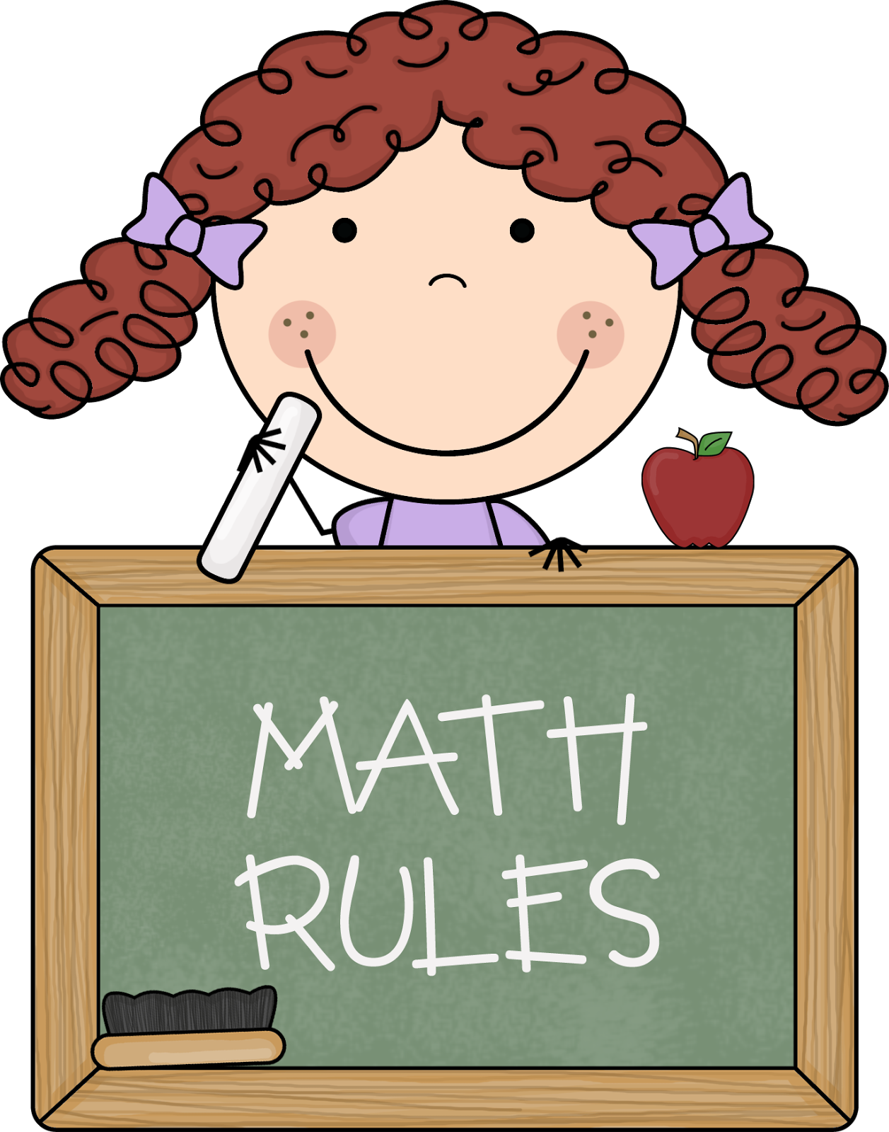
Contact Mrs. VanAsdlen:
mvanasdlen@min201.org
815.467.2261 ext. 1104

Upcoming Events:
- 1/15 - Martin Luther King-No School!
- 1/18 - Winter STEAM Family Night 6-7pm
- 1/26 - 5 Hour Day!
Writing
Students will learn how to identify and use adjectives to describe hot cocoa. This month’s writing topics will be based around winter activities, snowflakes, and snowmen.

