|  |  |
| --- | --- |
| **Date** | **Homework** |
| **Monday 12/18** | None |
| **Tuesday 12/19** | None |
| **Wednesday 12/20** | None |
| **Thursday 12/21** | None |
| **Friday 12/22** | **5 Hour Day! –Winter Break Begins** |



**Mrs. VanAsdlen’s Weekly Newsletter:**

December 18th – 22nd

**Special Notes!**

1. Over break, I will be sending home a packet of work that your child may complete if you would like them to. If completed, I will have a little something special for their hard work! I have created this packet so students can continue to build their Kindergarten skills over our long holiday break.
2. Winter is here and more snow is coming! Please remember to send the MAGIC 5 with your child each day. The MAGIC 5 includes: hat, gloves, boots, snow pants, and a coat. All students must have their MAGIC 5 with them in order to play in the snow during the winter season. All children without snow pants and boots will play on the blacktop area.
3. **Friday, December 22nd** please allow your child to wear their pajamas as PTO has a school-wide Polar Express themed assembly for the students on this early dismissal day. If your child is unable to participate in this holiday themed day, please let me know and we will make accommodations!
4. I hope everyone enjoys their winter break and spends quality time this holiday season with all your family and friends! Merry Christmas and Happy New Years!



**Pizza Hut Coupon!**

Continue to teach your child to love reading! **December reading logs will be due after Winter Break.** January reading logs will be sent home when we return.



**Phonics:**

* Short /i/ word families: **-ip** & **-in**
* Tricky Words- **live, give**

** As well as the homework listed above, I encourage your child to study his or her spelling words and dictation sentences on a nightly basis to prepare them for the test. Please also read for at least 20 minutes a day. This helps build their fluency, comprehension and love for reading! **

** As well as the homework listed above, I encourage your child to study his or her spelling words and dictation sentences on a nightly basis to prepare them for the test. Please also read for at least 20 minutes a day. This helps build their fluency, comprehension and love for reading! **

### https://sp.yimg.com/xj/th?id=OIP.Mfdb972c958fb182b4b79af2fda67a2bbH0&pid=15.1&P=0&w=300&h=300

**Math**

We will begin Chapter 6 *Subtraction* when we return from winter break. This week students will engaged in supplemental math activities with the previously learned concepts.

** As well as the homework listed above, I encourage your child to study his or her spelling words and dictation sentences on a nightly basis to prepare them for the test. Please also read for at least 20 minutes a day. This helps build their fluency, comprehension and love for reading! **

**Reading Strategy:**

Students will read non-fiction texts about reindeers and complete numerous activities to build their schema.

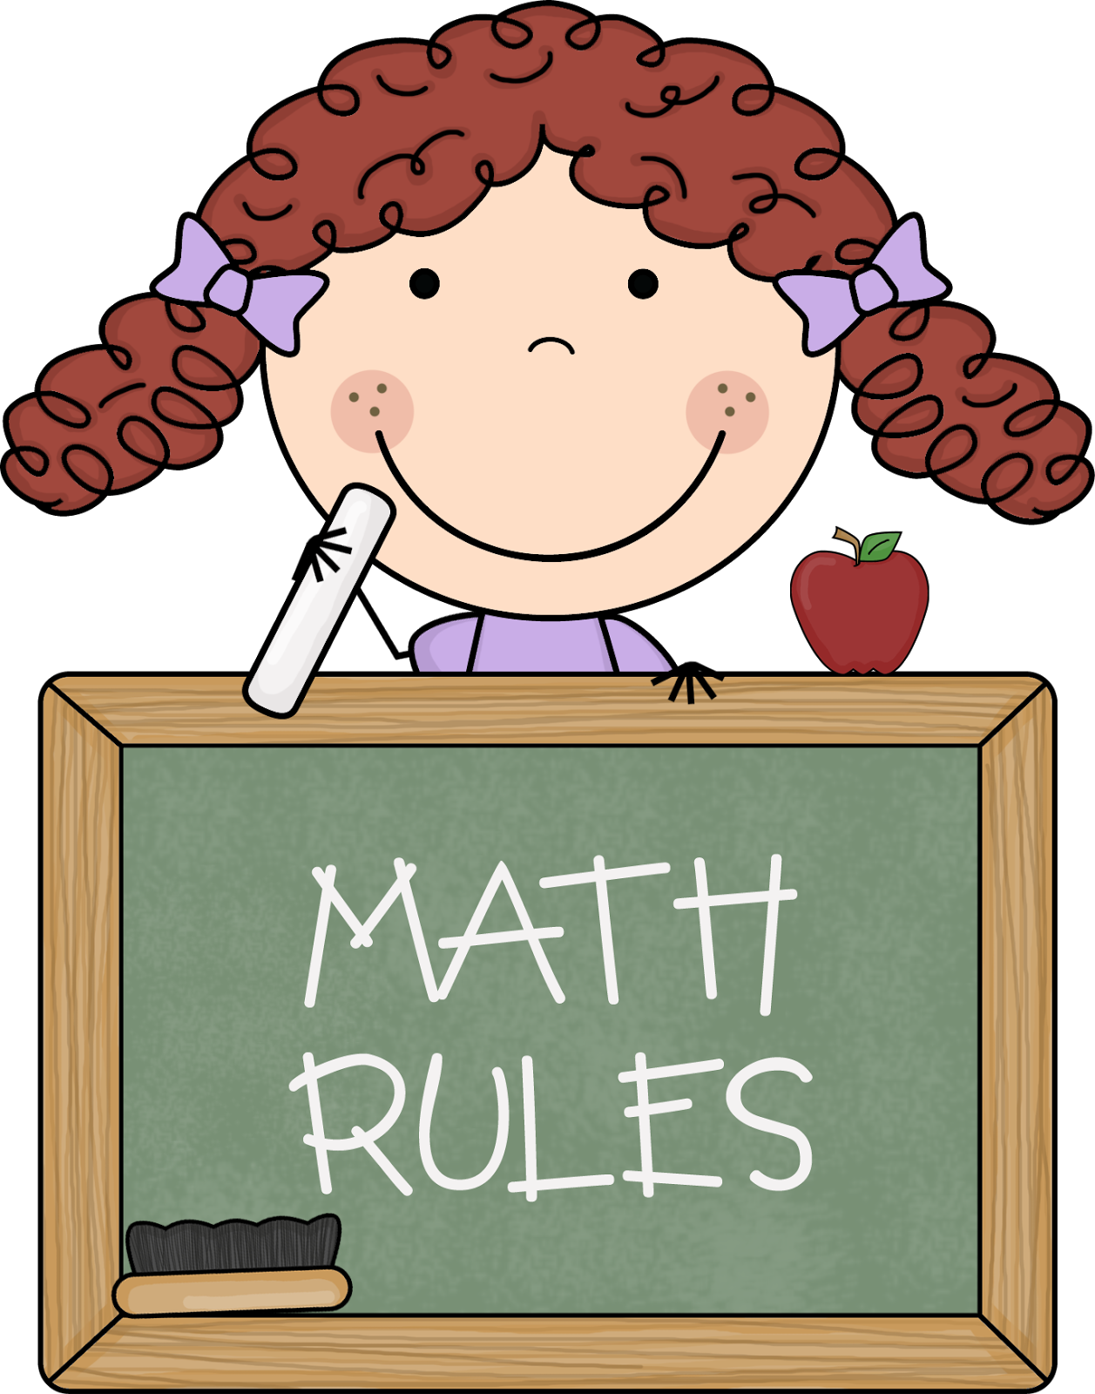

Upcoming Events:

* **12/22- 5 Hour Day!-**PTO’s Winter Celebration (pajama day)
* 12/23-1/8—WINTER Break!
* 12/9- School Resumes



Contact Mrs. VanAsdlen:  
[mvanasdlen@min201.org](mailto:mvanasdlen@min201.org)  
815.467.2261 ext. 1104

**Writing**

Students will use adjectives to describe the season of winter. Our elf has also given us numerous kindness deeds to complete this week!