Date | Homework
Monday 12/11 | Math: None  Phonics: Share Sheet #7
Tuesday 12/12 | Math: None  Phonics: Share Sheet #7 due!
Wednesday 12/13 | Math: None  Phonics: Read, Read, Read
Thursday 12/14 | Math: Study for Chapter 5 Test!  Phonics: Read, Read, Read
Friday 12/15 | Math: Chapter 5 Test!
Mrs. VanAsdlen’s Weekly Newsletter:
December 11th - 15th

Special Notes!
- MES has officially begun our annual winter clothing drive. Any donated winter clothes will be accepted now through January. We appreciate your thoughtfulness this holiday season!
- Please visit our classroom website with new updated pictures from our elf, Shuggy! https://k2mreyes.weebly.com

Reading Log
Continue to teach your child to love reading! December reading logs for Pizza Hut coupons will be due after Winter Break. January reading logs will be sent out when students return from break.

Reading Strategy:
Students will retell Gingerbread Man & Gingerbread Girl. Then, they will compare and contrast the two stories using a Venn Diagram.
** As well as the homework listed above, I encourage your child to study his or her spelling words and dictation sentences on a nightly basis to prepare them for the test. Please also read for at least 20 minutes a day. This helps build their fluency, comprehension and love for reading! **

Phonics:
- Tricky Words- like, have
- Word Family- short a, -am & -ap
- Share Sheet #7 will be due on Tuesday, December 12th.

** As well as the homework listed above, I encourage your child to study his or her spelling words and dictation sentences on a nightly basis to prepare them for the test. Please also read for at least 20 minutes a day. This helps build their fluency, comprehension and love for reading! **

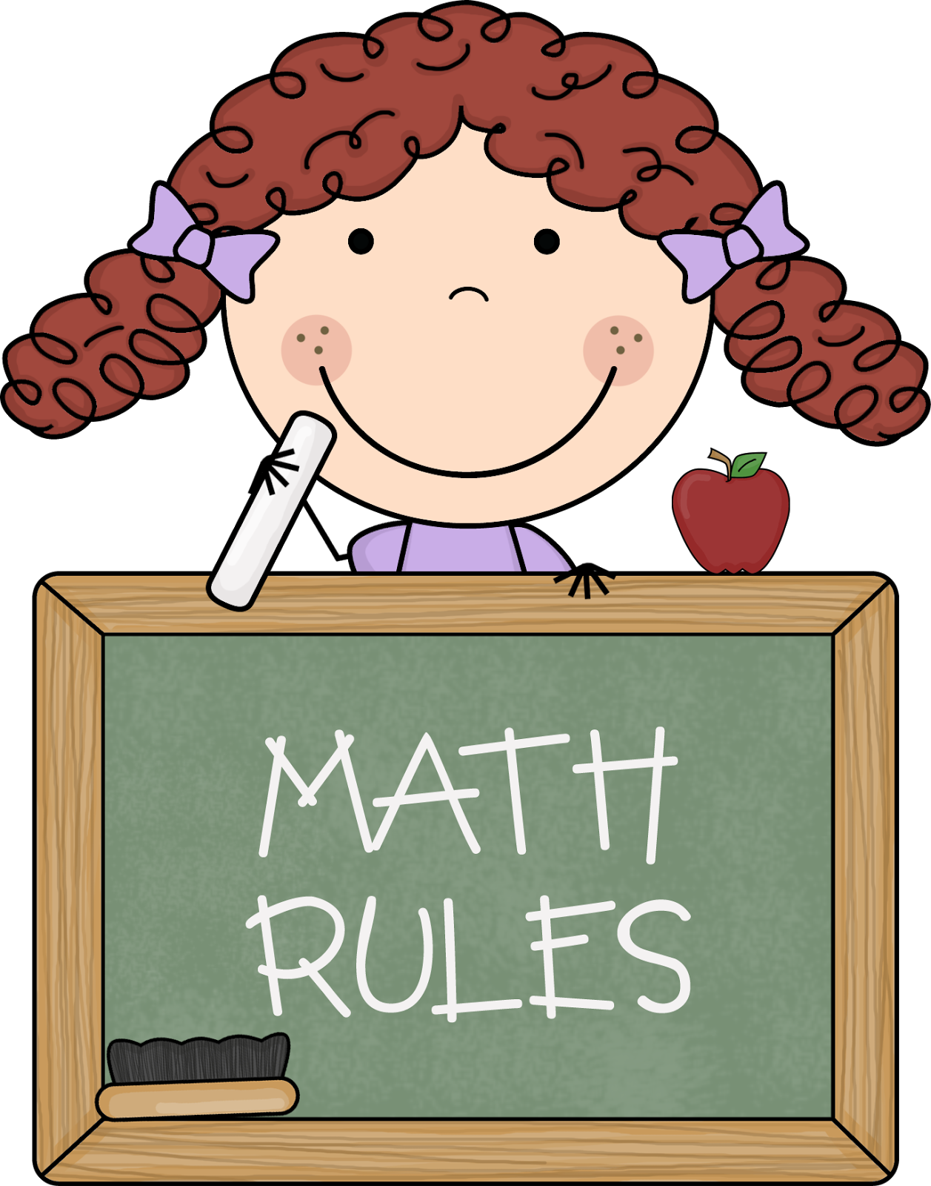
Math
Students will take the Chapter 5 Addition test on Friday, December 15th. This will be the first test taken as a grade and recorded on your child’s 2nd trimester report card. Please take the time to review the practice test that will be sent home on Thursday. We will begin Chapter 6 Subtraction when we return from Winter Break.

Science
Students will use the Scientific Method for a Gingerbread experiment to see what happens if the gingerbread man would have jumped in the water.
** As well as the homework listed above, I encourage your child to study his or her spelling words and dictation sentences on a nightly basis to prepare them for the test. Please also read for at least 20 minutes a day. This helps build their fluency, comprehension and love for reading! **

Upcoming Events:
- 12/15- PTO Store
- 12/22- 5 Hour Day!-PTO’s Winter Celebration
- 12/23-1/8—WINTER Break!
- 12/9- Return back to school!
Writing
Our writing unit will focus on how to make good word choices when writing. Students will continue to learn how to use adjectives to describe nouns.
We will also continue writing sentences in our writing journals.
Contact Mrs. VanAsdlen:
mvanasdlen@min201.org
815.467.2261 ext. 1104

