Date | Homework
Monday 10/23 | Math: 4.3  Phonics: Share Sheet #5
Tuesday 10/24 | Math: 4.4  Phonics: Share Sheet #5
Wednesday 10/25 | Math: 4.5  Phonics: Share Sheet #5
Thursday 10/26 | Math: 4.6  Phonics: Share Sheet #5 Due!
Friday 10/27 5 hour day! | Read, Read, Read!!
Mrs. VanAsdlen’s Weekly Newsletter:
October 23rd – 27th

Special Notes!
- MES Book Fair will be take place this week. On Monday, students will have a chance to browse at the book fair as a class. Then, the remainder of the week, they will be sent down with our aide to buy books. Dress up days are as followed for our book fair week: Monday-Wild West Day, Tuesday-Favorite Character Day, Wednesday-Hero Day, Thursday-Future Day, Friday-Halloween Costume!
- Friday, October 27th, we will celebrate Halloween! Students can dress in their costumes! Please, NO face paint or fake weapons. At approximately 10:00a.m. students will march in our Trunk-or -Treat parade around the front of the school. All families are welcome to watch!
- Friday, October 27th is also a 5 Hour early dismissal day! There is no school on Monday, October 30th as well!
- On the actual day of Halloween, Tuesday October 31st, please refrain from sending students in their Halloween costumes, instead we will be having a Pumpkin Investigation rotation day to celebrate.

Phonics:
- Frieze 6- students will recognize, write and know the sounds for th (voiced and unvoiced). The remainder of the week we will take to review previous letters/sounds learned. Please practice flashcards daily!
- Tricky Words- students will recognize and spell: you, your (these words are “tricky” because they cannot be sounded out).
- Share Sheet #5 is due on Thursday, October 26th.

** As well as the homework listed above, I encourage your child to study his or her spelling words and dictation sentences on a nightly basis to prepare them for the test. Please also read for at least 20 minutes a day. This helps build their fluency, comprehension and love for reading! **

** As well as the homework listed above, I encourage your child to study his or her spelling words and dictation sentences on a nightly basis to prepare them for the test. Please also read for at least 20 minutes a day. This helps build their fluency, comprehension and love for reading! **

Math
We will continue with Chapter 4 Represent and Compare Numbers to 10.

Science: Pumpkin Patch Experiment
Last week our class formed a question and a hypothesis for growing pumpkin seeds in our classroom. This week we will continue to be scientists by observing and drawing what we see.
** As well as the homework listed above, I encourage your child to study his or her spelling words and dictation sentences on a nightly basis to prepare them for the test. Please also read for at least 20 minutes a day. This helps build their fluency, comprehension and love for reading! **

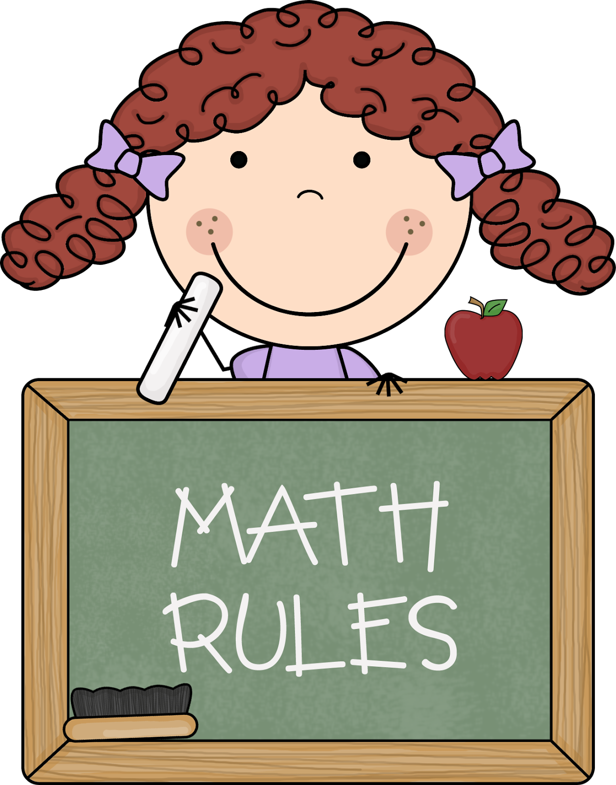
Upcoming Events:
- 10/23-10/27 –PTO Book Fair (dress up days)
- 10/27 Halloween Celebration w/ costumes & Trunk-or-Treat Parade @ 10:00a.m.
- 10/27 5 Hour Day!
- 10/27 Fall Fest from 6-8 p.m. for MES families
- 10/30 No School-Teacher Institute
- 10/31 Halloween (no costumes)

Writing
Our writing unit will focus on how students can organize their thoughts and understandings. They will be sequencing using transition words, first, next, then, and last for numerous Halloween writing activities.
Contact Mrs. VanAsdlen:
mvanasdlen@min201.org
815.467.2261 ext. 1104

